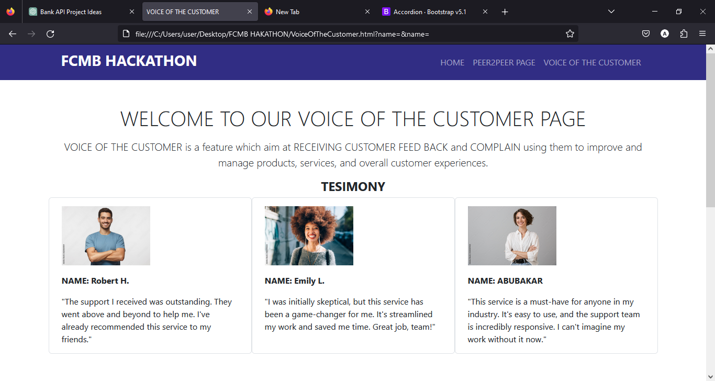

TESTIMONY SECTION

HOME

PEER2PEER SECTION

VOICE OF THE CUSTOMER SECTION

**FEED BACK FORM SECTION**

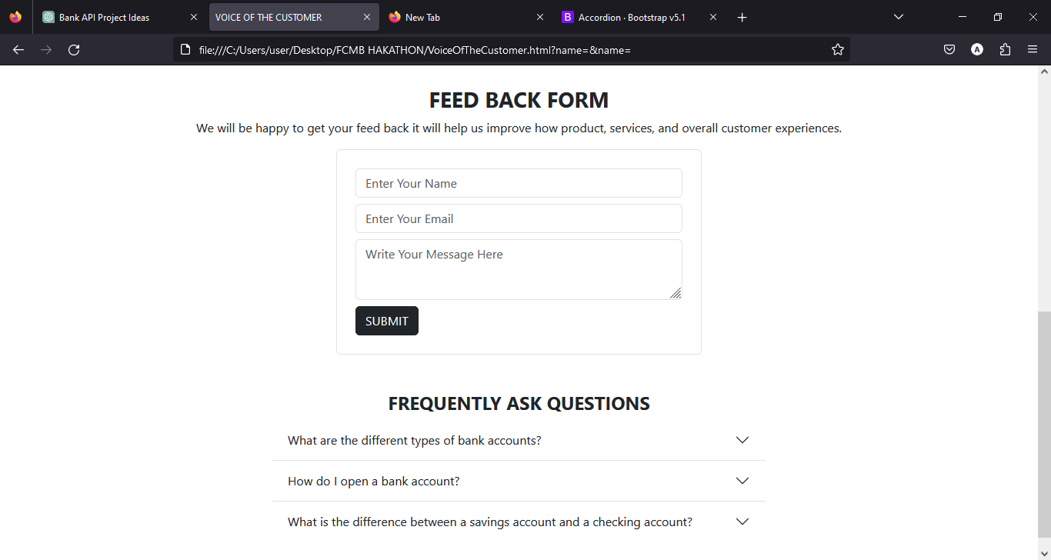

FREQUNTLY ASK QUESTION SECTION

FEED BACK FORM